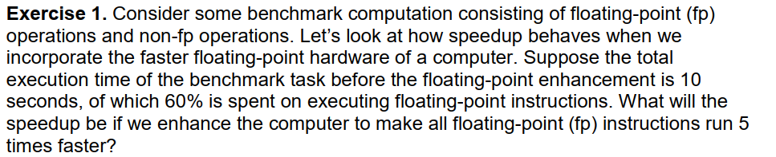

T=4s+6s=10s

T'=4s +( 6 / 5)s  
=5.2s

Where T is the total execution time before enhancement and T' is the total execution time after enhancement

Speedup = 10 s / 5.2 s

=1.923s

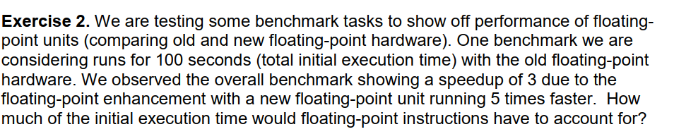

**(1)**

*T*=*t*1+*t*2=100*s*where T is the total execution time before enhancement.  
  
Speedup = *T / T '*= 100*s /T '*=3

**(2)** *T '*=*t*1+*t*2*'*=33.33 *s*where T' is the total execution time after enhancement  
t2' is the floating point execution time after enhancement

**(3)**  
*t*2 /*t*2*'* =5

Substitute into **(2),** *T'*=*t*1+(*t*2/5)  
=33.33 *s*

**(1) - (3)** =*T*-*T '*=*t*2-(*t/*25)  
=100 *s*-33.33*s*=66.66*s*

*t*2=83.33*s  
initial floating*- *point executiontime / initial executiontime*

=*t*2/*T*=83.33*s/* 100*s*=83.33 %

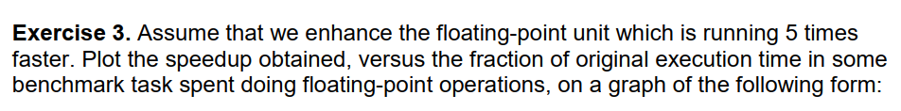

*T*=*t*1+*t*2

*T '*=*t*1+(*t*2 / 5)  
*Speedup*= *T/T '*=*T/ (t*1+( *t*2 / 5))  
=*T/ (* (*T*-*t*2)+ (*t*2 / 5))  
=*T/ (T*- 4/5(*t*2))  
= 1 / (1 – 4/5*( *t*2/T))  
 *if y*=*Speedup,*

*x*=*t*2/*T*

Then y = 1/ (1-0.8x)

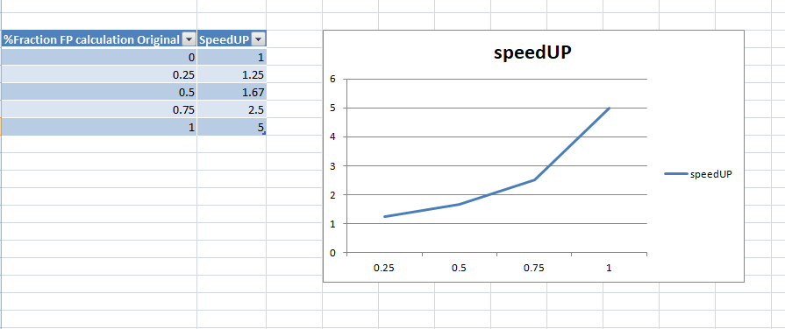

**TASK(II):**

